Temas del segundo parcial de Inglés

Los temas que tenemos que saber (por simple inspección ocular y según charlamos en el grupo) son, cómo máximo, los siguientes:

* Sentence analysis
  + Articles, Nouns, Adjetives, Verbs, Prepositions, Adverbs, Conjunctions, **Defining relative Clause** (si hacemos *Defining relative clause* somos cracks, según la profe suma XP (?)).
* Explanation of the PC and their parts:
  + Arithmethic Logic Unit
  + Control Unit
  + PC Peripherals (Keyboard, Mouse, Speakers, Monitor, etc).
* Databases (Unit 4)
* E-commerce (Unit 5)
* Network systems (Unit 6)
* Data processing

Resúmen

Sentence Analysis

* Articles: defines a noun in time, gender, number or space. For example: “the”, “a” / “an”, “he”, “she”, “it”. + info: <https://www.grammarly.com/blog/articles/>
* Nouns: It’s an object or name. For example: “**Chiqui**”, “**Computer**”, “**Book**”, etc.
* Adjetives: defines the attributes of the noun. For Example: “She is a **smart** girl”, “It was a **delicious** dinner”, “A **bad** idea”.
* Verbs: defines the type of an action. For example: “He’s **running** to nowhere”, “They **play** Airsoft”.
* Prepositions tell us where or when something is in relation to something else. For example: “I’m going **to** the office”, “Your notebook it’s **on** the kitchen table”.
* Adverbs: modify the verb and tells us what way someone does something. Adverbs often end in -ly. For example: “**Fortunately**, she recorded Sacachispas’ win”, “Chiqui is **very** tall”, “My car didn’t run **badly**”.
* Conjunctions / Connectors: generally connects two clauses, For example: “**For**”, “**And**”, “**Nor**”, “**But**” / “**Because**”, “**Or**”, “**Yet**” and “**So**”. Regla memotécnica >> FANBOYS.
* Defining relative clause: give us essential information about someone or something, in order to understand what or who is being referred to. This definition usually comes after the noun that’s describes. For example: “They’re the people **who want to buy our house**”, “They’re the people **she met at Jon’s party**”, “Here are some cells **that have been affected**“. Atention: the comma brokes this.

Explanation of the PC and their parts

* Arithmethic Logic Unit: Is an electronic circuit which realize arithmetical operations in binary code. This’s in contrast to a floating point unit, which operates with decimal numbers. It’s integrated in CPUs, FPUs and GPUs. A simple GPU may contain multiple ALUs.

The input of the ALU is the data which will be operated (operants) and an extra code which indicates the type of operation to be realized.

* Control Unit: Is an electronic circuit that controls the internal and external comunication relative to the processor. Translates and manages memory access, time signals, instructions, etc; And guarantee that the output instructions of the CPU are correctly performed, otherwise propose corrections.

Databases (Unit 4)

* What’s data collection? Is the systematic approach to gathering and measuring information from different sources.
* What’s data coding and data validation? Is the refinement of the data: assings labels to the important data and removes what’s not necesary or provide corrections.
* What’s data entry? Is the action of enter data to the database system.
* What’s data tabulation? Is the action of sort out data into categories.
* What’s data sorting? Is the process that involves arranging the data in order.

E-commerce (Unit 5)

pili piti fláutica

Network Systems (Unit 6)

* LAN: a fast internal connection throught computers in a reduced geographical space (for example, a department).
* MAN: is a connection between 2 or more LANs at high speed. The limit distance is 50 kilometers or less.
* WAN: the WAN most popular is Internet, which has almost entire world in it (está bien redactado esa frase?) and the speed depends of your Internet company and the external servers (relative to your LAN or MAN).
* VPN: it’s a Virtual Private Network. Your real IP is masked with a new IP provided for the city where the VPN it is. You can connect with the VPN to enter in secure LAN-Like network.
* Remote connection: There are many remote softwares which have the ability to controll another device like your remote controls the TV. In other words, it give you the posibility to control a PC or other device from the distance (you could stay in Argentina while control a server in Canada).
* Gateway: an interface providing a compatibility between networks by converting transmission speeds, protocols, codes, or security measures.
* Router: It forwards data packets from fastest route to internal and external packets going to/from Internet.
* Repeater hub: Connects multiple Ethernet devices together and making them act as a single network segment. It has multiple input/output (I/O) ports, in which a signal introduced at the input of any port appears at the output of every port except the original incoming. Hubs are now largely obsolete, having been replaced by network switches.
* Switch: a device that connects devices together on a computer network, by using packet switching to receive, process and forward data to the destination device. Unlike less advanced network hubs, a network switch forwards data only to one or multiple devices that need to receive it, rather than broadcasting the same data out of each of its ports.
* Wireless Access Point: a device which share the network through WiFi.
* Bridge: a device that connects multiple network segments.
* Repeater: an electronic device that receives a signal and retransmits it at a higher level or higher power, or onto the other side of an obstruction, so that the signal can cover longer distances.

Data processing

* Online: The data are sincronized between the server (internet) and a local computer.
* Per blocks: It’s an application which runs without supervision and handle big workloads.
* Real time: The data is stored in a local server of the LAN or MAN network. You can edit your files stored in the server at very high speeds (closest to “real time” with speeds between 100MB/s and 800MB/s depending of the type of server). Sometimes, you can use their processing power.
* Parallel Data Processing: Executes parallel operations thanks to (for example and isn’t limited to) various independent CPUs and Storage Drives.

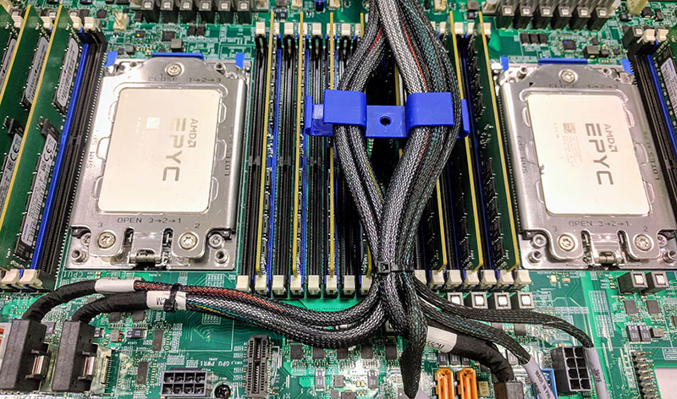  
REAL Parallel Data Processing thanks to 2xAMD Epyc Processors with 64 cores each of them

* Distributed Data Processing: It uses various machines connected in LAN to perform an operation together (one operation distributed through various PCs in LAN).